1,0.5,1

1 run......

Downloading: 100%

464/464 [00:00<00:00, 17.1kB/s]

Downloading: 100%

270M/270M [00:23<00:00, 12.3MB/s]

training 1 epoch...

27.424970388412476 seconds used......

1 training finished! average train loss: 0.9285558492821806

evaluating...

Confusion matrix, without normalization

[[ 390 2 381]

[ 152 9 269]

[ 264 3 2062]]

Normalized confusion matrix

[[0.50452781 0.00258732 0.49288486]

[0.35348837 0.02093023 0.6255814 ]

[0.11335337 0.00128811 0.88535852]]

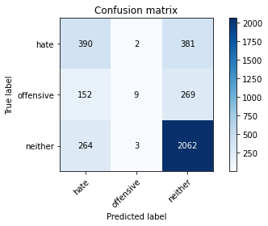

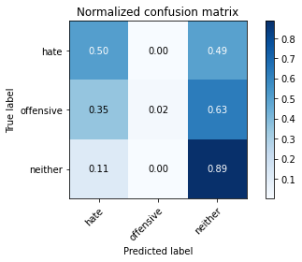

precision recall f1-score support

hate 0.48 0.50 0.49 773

offensive 0.64 0.02 0.04 430

neither 0.76 0.89 0.82 2329

accuracy 0.70 3532

macro avg 0.63 0.47 0.45 3532

weighted avg 0.69 0.70 0.65 3532

average eval_loss: 0.6918043367943522, accuracy: 0.6967723669309174

training 2 epoch...

26.548325061798096 seconds used......

2 training finished! average train loss: 0.6671612523496151

evaluating...

Confusion matrix, without normalization

[[ 352 79 342]

[ 82 164 184]

[ 191 106 2032]]

Normalized confusion matrix

[[0.45536869 0.10219922 0.44243208]

[0.19069767 0.38139535 0.42790698]

[0.08200945 0.0455131 0.87247746]]

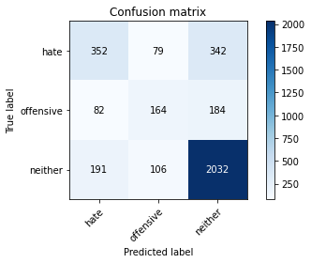

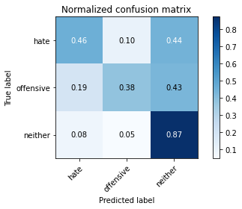

precision recall f1-score support

hate 0.56 0.46 0.50 773

offensive 0.47 0.38 0.42 430

neither 0.79 0.87 0.83 2329

accuracy 0.72 3532

macro avg 0.61 0.57 0.59 3532

weighted avg 0.70 0.72 0.71 3532

average eval_loss: 0.6475020886141029, accuracy: 0.7214043035107588

training 3 epoch...

26.504839420318604 seconds used......

3 training finished! average train loss: 0.4329421341638355

evaluating...

Confusion matrix, without normalization

[[ 340 72 361]

[ 83 155 192]

[ 150 110 2069]]

Normalized confusion matrix

[[0.43984476 0.0931436 0.46701164]

[0.19302326 0.36046512 0.44651163]

[0.06440532 0.04723057 0.8883641 ]]

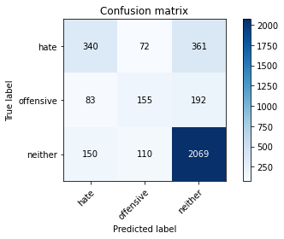

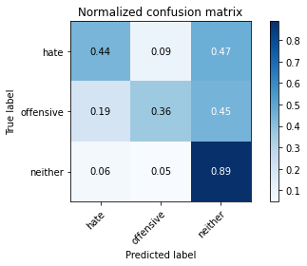

precision recall f1-score support

hate 0.59 0.44 0.51 773

offensive 0.46 0.36 0.40 430

neither 0.79 0.89 0.84 2329

accuracy 0.73 3532

macro avg 0.61 0.56 0.58 3532

weighted avg 0.71 0.73 0.71 3532

average eval_loss: 0.7199871038312966, accuracy: 0.7259343148357871

training 4 epoch...

26.552154541015625 seconds used......

4 training finished! average train loss: 0.2397197351023993

evaluating...

Confusion matrix, without normalization

[[ 452 84 237]

[ 117 179 134]

[ 337 162 1830]]

Normalized confusion matrix

[[0.5847348 0.10866753 0.30659767]

[0.27209302 0.41627907 0.31162791]

[0.14469729 0.06955775 0.78574495]]

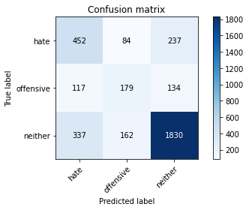

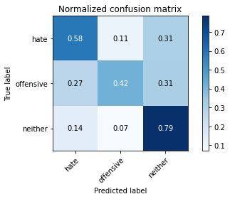

precision recall f1-score support

hate 0.50 0.58 0.54 773

offensive 0.42 0.42 0.42 430

neither 0.83 0.79 0.81 2329

accuracy 0.70 3532

macro avg 0.58 0.60 0.59 3532

weighted avg 0.71 0.70 0.70 3532

average eval_loss: 0.8748050128336007, accuracy: 0.6967723669309174

training 5 epoch...

26.486582279205322 seconds used......

5 training finished! average train loss: 0.113027467734783

evaluating...

Confusion matrix, without normalization

[[ 388 163 222]

[ 66 246 118]

[ 256 309 1764]]

Normalized confusion matrix

[[0.50194049 0.21086675 0.28719276]

[0.15348837 0.57209302 0.2744186 ]

[0.10991842 0.13267497 0.75740661]]

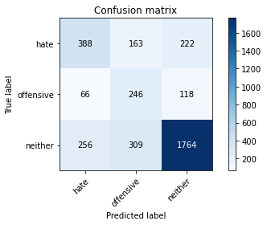

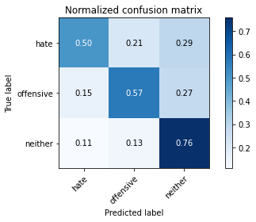

precision recall f1-score support

hate 0.55 0.50 0.52 773

offensive 0.34 0.57 0.43 430

neither 0.84 0.76 0.80 2329

accuracy 0.68 3532

macro avg 0.58 0.61 0.58 3532

weighted avg 0.71 0.68 0.69 3532

average eval_loss: 1.1163923663776474, accuracy: 0.6789354473386183

training 6 epoch...

26.532782554626465 seconds used......

6 training finished! average train loss: 0.041930933280930144

evaluating...

Confusion matrix, without normalization

[[ 419 134 220]

[ 86 230 114]

[ 307 280 1742]]

Normalized confusion matrix

[[0.54204398 0.17335058 0.28460543]

[0.2 0.53488372 0.26511628]

[0.13181623 0.12022327 0.7479605 ]]

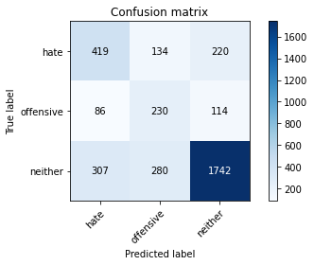

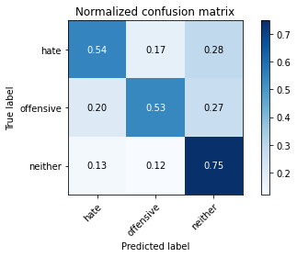

precision recall f1-score support

hate 0.52 0.54 0.53 773

offensive 0.36 0.53 0.43 430

neither 0.84 0.75 0.79 2329

accuracy 0.68 3532

macro avg 0.57 0.61 0.58 3532

weighted avg 0.71 0.68 0.69 3532

average eval_loss: 1.271589961976318, accuracy: 0.6769535673839184

training 7 epoch...

26.513099908828735 seconds used......

7 training finished! average train loss: 0.01610237673123586

evaluating...

Confusion matrix, without normalization

[[ 340 127 306]

[ 64 219 147]

[ 164 204 1961]]

Normalized confusion matrix

[[0.43984476 0.16429495 0.39586028]

[0.14883721 0.50930233 0.34186047]

[0.07041649 0.08759124 0.84199227]]

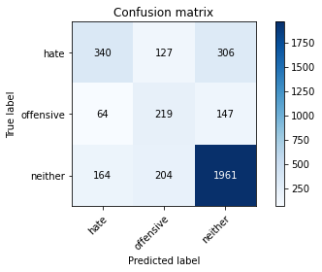

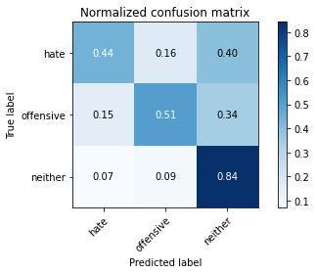

precision recall f1-score support

hate 0.60 0.44 0.51 773

offensive 0.40 0.51 0.45 430

neither 0.81 0.84 0.83 2329

accuracy 0.71 3532

macro avg 0.60 0.60 0.59 3532

weighted avg 0.72 0.71 0.71 3532

average eval_loss: 1.3126844214643798, accuracy: 0.7134767836919592

training 8 epoch...

26.525720596313477 seconds used......

8 training finished! average train loss: 0.015529306241232381

evaluating...

Confusion matrix, without normalization

[[ 428 87 258]

[ 101 193 136]

[ 291 181 1857]]

Normalized confusion matrix

[[0.55368693 0.11254851 0.33376455]

[0.23488372 0.44883721 0.31627907]

[0.12494633 0.07771576 0.79733791]]

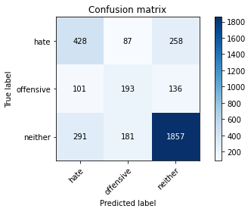

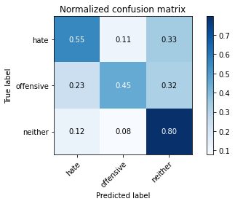

precision recall f1-score support

hate 0.52 0.55 0.54 773

offensive 0.42 0.45 0.43 430

neither 0.82 0.80 0.81 2329

accuracy 0.70 3532

macro avg 0.59 0.60 0.59 3532

weighted avg 0.71 0.70 0.71 3532

average eval_loss: 1.3754936100462567, accuracy: 0.70158550396376

training 9 epoch...

26.46067976951599 seconds used......

9 training finished! average train loss: 0.01307567398137454

evaluating...

Confusion matrix, without normalization

[[ 380 96 297]

[ 76 189 165]

[ 218 133 1978]]

Normalized confusion matrix

[[0.4915912 0.12419146 0.38421734]

[0.17674419 0.43953488 0.38372093]

[0.0936024 0.05710605 0.84929154]]

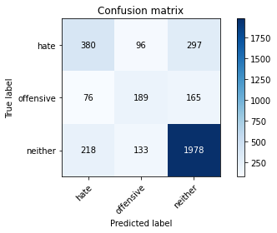

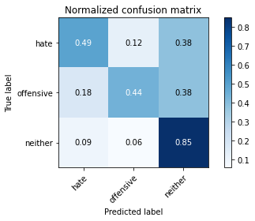

precision recall f1-score support

hate 0.56 0.49 0.53 773

offensive 0.45 0.44 0.45 430

neither 0.81 0.85 0.83 2329

accuracy 0.72 3532

macro avg 0.61 0.59 0.60 3532

weighted avg 0.71 0.72 0.72 3532

average eval_loss: 1.3935843631651483, accuracy: 0.7211211778029445

training 10 epoch...

26.544464111328125 seconds used......

10 training finished! average train loss: 0.017766387429540318

evaluating...

Confusion matrix, without normalization

[[ 380 181 212]

[ 70 251 109]

[ 261 363 1705]]

Normalized confusion matrix

[[0.4915912 0.23415265 0.27425614]

[0.1627907 0.58372093 0.25348837]

[0.11206526 0.15586088 0.73207385]]

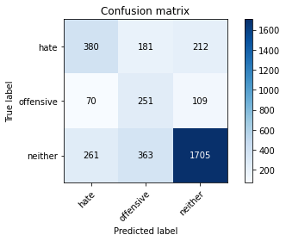

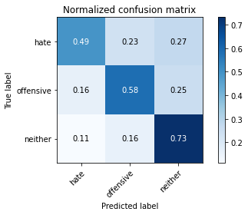

precision recall f1-score support

hate 0.53 0.49 0.51 773

offensive 0.32 0.58 0.41 430

neither 0.84 0.73 0.78 2329

accuracy 0.66 3532

macro avg 0.56 0.60 0.57 3532

weighted avg 0.71 0.66 0.68 3532

average eval_loss: 1.6325297273148252, accuracy: 0.6613816534541337

2 run......

training 1 epoch...

26.672195434570312 seconds used......

1 training finished! average train loss: 0.875082615762949

evaluating...

Confusion matrix, without normalization

[[ 500 12 261]

[ 195 26 209]

[ 389 29 1911]]

Normalized confusion matrix

[[0.64683053 0.01552393 0.33764554]

[0.45348837 0.06046512 0.48604651]

[0.16702447 0.0124517 0.82052383]]

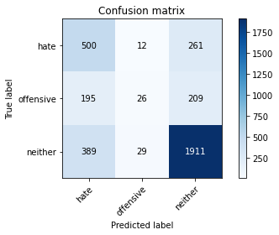

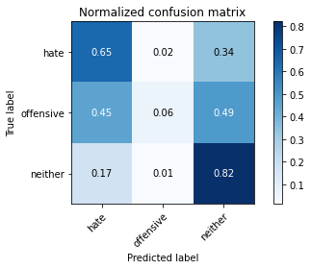

precision recall f1-score support

hate 0.46 0.65 0.54 773

offensive 0.39 0.06 0.10 430

neither 0.80 0.82 0.81 2329

accuracy 0.69 3532

macro avg 0.55 0.51 0.48 3532

weighted avg 0.68 0.69 0.67 3532

average eval_loss: 0.6733140623838888, accuracy: 0.6899773499433749

training 2 epoch...

26.56351399421692 seconds used......

2 training finished! average train loss: 0.6297101299552357

evaluating...

Confusion matrix, without normalization

[[ 376 46 351]

[ 115 104 211]

[ 188 66 2075]]

Normalized confusion matrix

[[0.48641656 0.05950841 0.45407503]

[0.26744186 0.24186047 0.49069767]

[0.08072134 0.02833834 0.89094032]]

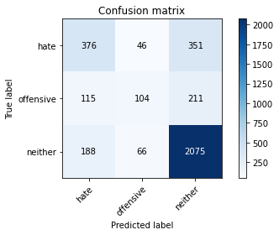

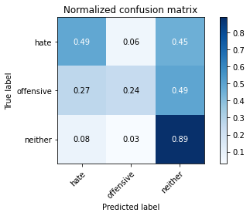

precision recall f1-score support

hate 0.55 0.49 0.52 773

offensive 0.48 0.24 0.32 430

neither 0.79 0.89 0.84 2329

accuracy 0.72 3532

macro avg 0.61 0.54 0.56 3532

weighted avg 0.70 0.72 0.70 3532

average eval_loss: 0.6263427067611177, accuracy: 0.7233861834654587

training 3 epoch...

26.495060205459595 seconds used......

3 training finished! average train loss: 0.4181974629926331

evaluating...

Confusion matrix, without normalization

[[ 497 30 246]

[ 190 89 151]

[ 337 78 1914]]

Normalized confusion matrix

[[0.64294955 0.03880983 0.31824062]

[0.44186047 0.20697674 0.35116279]

[0.14469729 0.03349077 0.82181194]]

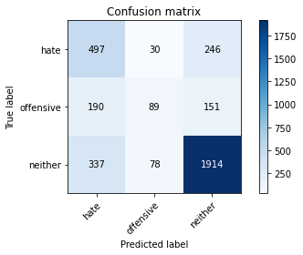

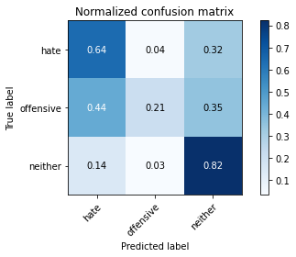

precision recall f1-score support

hate 0.49 0.64 0.55 773

offensive 0.45 0.21 0.28 430

neither 0.83 0.82 0.83 2329

accuracy 0.71 3532

macro avg 0.59 0.56 0.55 3532

weighted avg 0.71 0.71 0.70 3532

average eval_loss: 0.6844716936686618, accuracy: 0.7078142695356738

training 4 epoch...

26.54197645187378 seconds used......

4 training finished! average train loss: 0.24491792109192295

evaluating...

Confusion matrix, without normalization

[[ 323 177 273]

[ 51 237 142]

[ 190 259 1880]]

Normalized confusion matrix

[[0.41785252 0.22897801 0.35316947]

[0.11860465 0.55116279 0.33023256]

[0.08158008 0.11120653 0.8072134 ]]

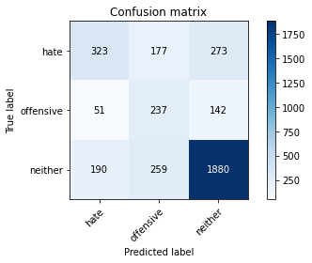

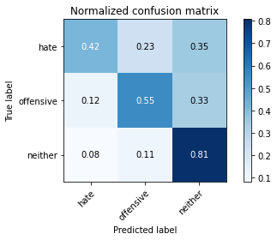

precision recall f1-score support

hate 0.57 0.42 0.48 773

offensive 0.35 0.55 0.43 430

neither 0.82 0.81 0.81 2329

accuracy 0.69 3532

macro avg 0.58 0.59 0.58 3532

weighted avg 0.71 0.69 0.69 3532

average eval_loss: 0.9088247339267516, accuracy: 0.6908267270668177

training 5 epoch...

26.647314071655273 seconds used......

5 training finished! average train loss: 0.10419678453164284

evaluating...

Confusion matrix, without normalization

[[ 390 70 313]

[ 103 146 181]

[ 220 104 2005]]

Normalized confusion matrix

[[0.50452781 0.09055627 0.40491591]

[0.23953488 0.33953488 0.42093023]

[0.09446114 0.04465436 0.8608845 ]]

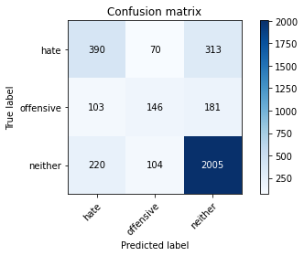

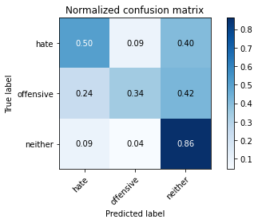

precision recall f1-score support

hate 0.55 0.50 0.52 773

offensive 0.46 0.34 0.39 430

neither 0.80 0.86 0.83 2329

accuracy 0.72 3532

macro avg 0.60 0.57 0.58 3532

weighted avg 0.70 0.72 0.71 3532

average eval_loss: 1.0059306657752074, accuracy: 0.7194224235560589

training 6 epoch...

26.59060788154602 seconds used......

6 training finished! average train loss: 0.04514465780298719

evaluating...

Confusion matrix, without normalization

[[ 416 105 252]

[ 105 179 146]

[ 262 178 1889]]

Normalized confusion matrix

[[0.538163 0.13583441 0.32600259]

[0.24418605 0.41627907 0.33953488]

[0.11249463 0.07642765 0.81107772]]

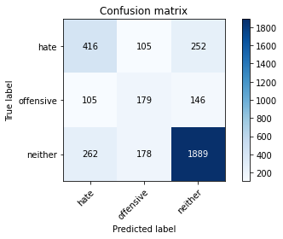

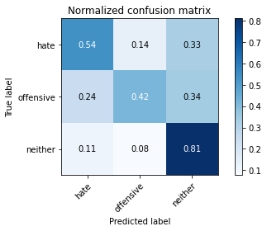

precision recall f1-score support

hate 0.53 0.54 0.53 773

offensive 0.39 0.42 0.40 430

neither 0.83 0.81 0.82 2329

accuracy 0.70 3532

macro avg 0.58 0.59 0.58 3532

weighted avg 0.71 0.70 0.71 3532

average eval_loss: 1.1823097392495743, accuracy: 0.7032842582106456

training 7 epoch...

26.557856798171997 seconds used......

7 training finished! average train loss: 0.021216673313414074

evaluating...

Confusion matrix, without normalization

[[ 451 113 209]

[ 122 198 110]

[ 356 230 1743]]

Normalized confusion matrix

[[0.58344114 0.1461837 0.27037516]

[0.28372093 0.46046512 0.25581395]

[0.1528553 0.09875483 0.74838987]]

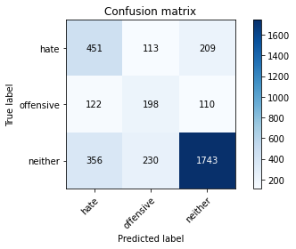

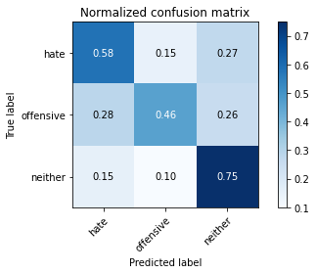

precision recall f1-score support

hate 0.49 0.58 0.53 773

offensive 0.37 0.46 0.41 430

neither 0.85 0.75 0.79 2329

accuracy 0.68 3532

macro avg 0.57 0.60 0.58 3532

weighted avg 0.71 0.68 0.69 3532

average eval_loss: 1.3626628464224648, accuracy: 0.6772366930917327

training 8 epoch...

26.49220609664917 seconds used......

8 training finished! average train loss: 0.013027794808080858

evaluating...

Confusion matrix, without normalization

[[ 458 109 206]

[ 111 203 116]

[ 350 225 1754]]

Normalized confusion matrix

[[0.59249677 0.14100906 0.26649418]

[0.25813953 0.47209302 0.26976744]

[0.15027909 0.09660799 0.75311292]]

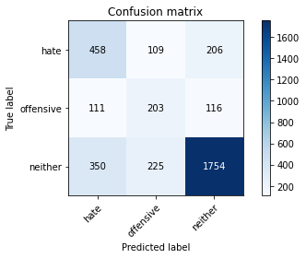

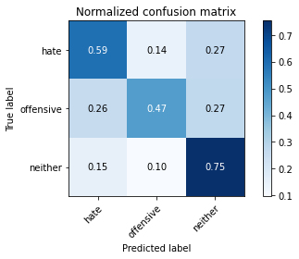

precision recall f1-score support

hate 0.50 0.59 0.54 773

offensive 0.38 0.47 0.42 430

neither 0.84 0.75 0.80 2329

accuracy 0.68 3532

macro avg 0.57 0.61 0.59 3532

weighted avg 0.71 0.68 0.69 3532

average eval_loss: 1.4531366308193423, accuracy: 0.6837485843714609

training 9 epoch...

26.499927520751953 seconds used......

9 training finished! average train loss: 0.006947974566120298

evaluating...

Confusion matrix, without normalization

[[ 430 93 250]

[ 108 178 144]

[ 300 158 1871]]

Normalized confusion matrix

[[0.55627426 0.12031048 0.32341527]

[0.25116279 0.41395349 0.33488372]

[0.12881065 0.06784027 0.80334908]]

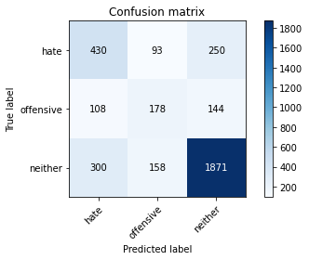

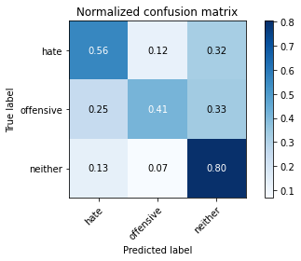

precision recall f1-score support

hate 0.51 0.56 0.53 773

offensive 0.41 0.41 0.41 430

neither 0.83 0.80 0.81 2329

accuracy 0.70 3532

macro avg 0.58 0.59 0.59 3532

weighted avg 0.71 0.70 0.70 3532

average eval_loss: 1.449679900023897, accuracy: 0.7018686296715742

training 10 epoch...

26.4983127117157 seconds used......

10 training finished! average train loss: 0.006653773203117239

evaluating...

Confusion matrix, without normalization

[[ 474 98 201]

[ 125 177 128]

[ 397 174 1758]]

Normalized confusion matrix

[[0.61319534 0.12677878 0.26002587]

[0.29069767 0.41162791 0.29767442]

[0.17045942 0.07471018 0.7548304 ]]

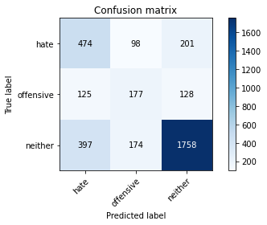

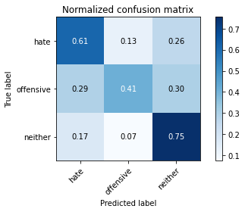

precision recall f1-score support

hate 0.48 0.61 0.54 773

offensive 0.39 0.41 0.40 430

neither 0.84 0.75 0.80 2329

accuracy 0.68 3532

macro avg 0.57 0.59 0.58 3532

weighted avg 0.71 0.68 0.69 3532

average eval_loss: 1.6541272274686791, accuracy: 0.6820498301245753

3 run......

training 1 epoch...

26.556166410446167 seconds used......

1 training finished! average train loss: 0.9476279964780107

evaluating...

Confusion matrix, without normalization

[[ 234 0 539]

[ 72 1 357]

[ 107 1 2221]]

Normalized confusion matrix

[[3.02716688e-01 0.00000000e+00 6.97283312e-01]

[1.67441860e-01 2.32558140e-03 8.30232558e-01]

[4.59424646e-02 4.29368828e-04 9.53628167e-01]]

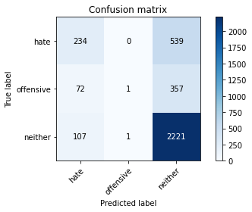

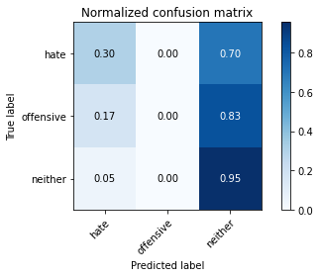

precision recall f1-score support

hate 0.57 0.30 0.39 773

offensive 0.50 0.00 0.00 430

neither 0.71 0.95 0.82 2329

accuracy 0.70 3532

macro avg 0.59 0.42 0.40 3532

weighted avg 0.65 0.70 0.62 3532

average eval_loss: 0.6710642601473856, accuracy: 0.695356738391846

training 2 epoch...

26.485560655593872 seconds used......

2 training finished! average train loss: 0.6661380176596782

evaluating...

Confusion matrix, without normalization

[[ 528 32 213]

[ 183 105 142]

[ 428 89 1812]]

Normalized confusion matrix

[[0.68305304 0.04139715 0.27554981]

[0.4255814 0.24418605 0.33023256]

[0.18376986 0.03821383 0.77801632]]

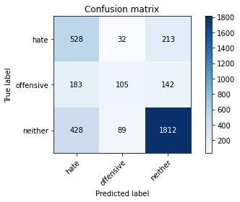

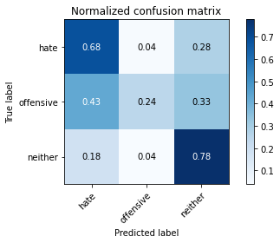

precision recall f1-score support

hate 0.46 0.68 0.55 773

offensive 0.46 0.24 0.32 430

neither 0.84 0.78 0.81 2329

accuracy 0.69 3532

macro avg 0.59 0.57 0.56 3532

weighted avg 0.71 0.69 0.69 3532

average eval_loss: 0.692916080776581, accuracy: 0.692242355605889

training 3 epoch...

26.511343717575073 seconds used......

3 training finished! average train loss: 0.43439133958343196

evaluating...

Confusion matrix, without normalization

[[ 422 92 259]

[ 118 184 128]

[ 311 181 1837]]

Normalized confusion matrix

[[0.54592497 0.11901682 0.33505821]

[0.2744186 0.42790698 0.29767442]

[0.13353371 0.07771576 0.78875054]]

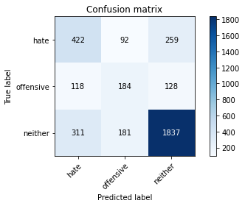

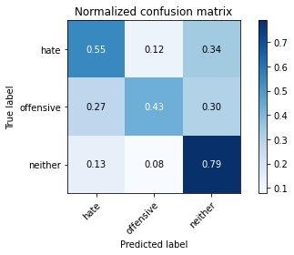

precision recall f1-score support

hate 0.50 0.55 0.52 773

offensive 0.40 0.43 0.41 430

neither 0.83 0.79 0.81 2329

accuracy 0.69 3532

macro avg 0.57 0.59 0.58 3532

weighted avg 0.70 0.69 0.70 3532

average eval_loss: 0.7552444744581557, accuracy: 0.6916761041902605

training 4 epoch...

26.53830313682556 seconds used......

4 training finished! average train loss: 0.2218876132632003

evaluating...

Confusion matrix, without normalization

[[ 391 129 253]

[ 79 204 147]

[ 278 191 1860]]

Normalized confusion matrix

[[0.50582147 0.16688228 0.32729625]

[0.18372093 0.4744186 0.34186047]

[0.11936453 0.08200945 0.79862602]]

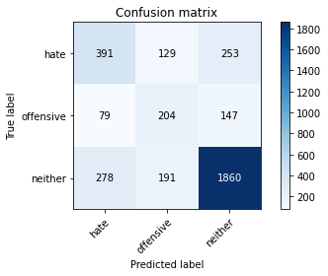

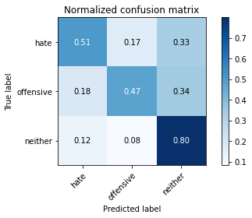

precision recall f1-score support

hate 0.52 0.51 0.51 773

offensive 0.39 0.47 0.43 430

neither 0.82 0.80 0.81 2329

accuracy 0.70 3532

macro avg 0.58 0.59 0.58 3532

weighted avg 0.70 0.70 0.70 3532

average eval_loss: 0.8767180199508613, accuracy: 0.6950736126840317

training 5 epoch...

26.504927396774292 seconds used......

5 training finished! average train loss: 0.09870900291785159

evaluating...

Confusion matrix, without normalization

[[ 374 134 265]

[ 79 206 145]

[ 240 209 1880]]

Normalized confusion matrix

[[0.48382924 0.17335058 0.34282018]

[0.18372093 0.47906977 0.3372093 ]

[0.10304852 0.08973809 0.8072134 ]]

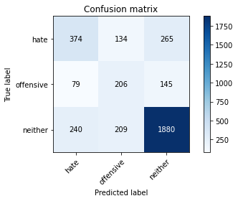

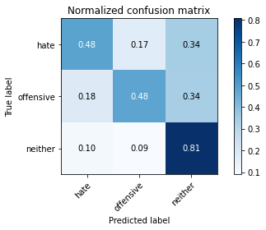

precision recall f1-score support

hate 0.54 0.48 0.51 773

offensive 0.38 0.48 0.42 430

neither 0.82 0.81 0.81 2329

accuracy 0.70 3532

macro avg 0.58 0.59 0.58 3532

weighted avg 0.71 0.70 0.70 3532

average eval_loss: 1.1230599250497117, accuracy: 0.6964892412231031

training 6 epoch...

26.548527240753174 seconds used......

6 training finished! average train loss: 0.04871328245944289

evaluating...

Confusion matrix, without normalization

[[ 336 109 328]

[ 67 172 191]

[ 185 138 2006]]

Normalized confusion matrix

[[0.43467012 0.14100906 0.42432083]

[0.15581395 0.4 0.44418605]

[0.07943323 0.0592529 0.86131387]]

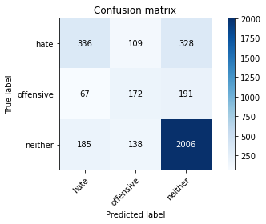

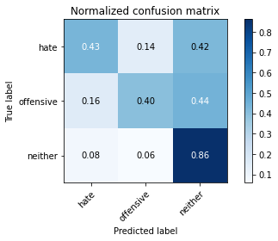

precision recall f1-score support

hate 0.57 0.43 0.49 773

offensive 0.41 0.40 0.41 430

neither 0.79 0.86 0.83 2329

accuracy 0.71 3532

macro avg 0.59 0.57 0.58 3532

weighted avg 0.70 0.71 0.70 3532

average eval_loss: 1.2136461893043948, accuracy: 0.7117780294450736

training 7 epoch...

26.49085259437561 seconds used......

7 training finished! average train loss: 0.02540402596915716

evaluating...

Confusion matrix, without normalization

[[ 436 112 225]

[ 101 208 121]

[ 345 208 1776]]

Normalized confusion matrix

[[0.56403622 0.14489004 0.29107374]

[0.23488372 0.48372093 0.28139535]

[0.14813225 0.08930872 0.76255904]]

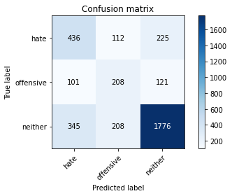

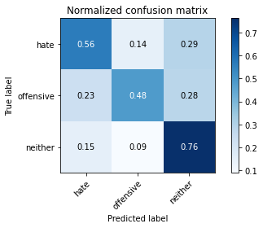

precision recall f1-score support

hate 0.49 0.56 0.53 773

offensive 0.39 0.48 0.43 430

neither 0.84 0.76 0.80 2329

accuracy 0.69 3532

macro avg 0.58 0.60 0.59 3532

weighted avg 0.71 0.69 0.69 3532

average eval_loss: 1.3804456935090534, accuracy: 0.6851642129105323

training 8 epoch...

26.522436141967773 seconds used......

8 training finished! average train loss: 0.013277531696504037

evaluating...

Confusion matrix, without normalization

[[ 383 150 240]

[ 75 236 119]

[ 271 280 1778]]

Normalized confusion matrix

[[0.49547219 0.19404916 0.31047865]

[0.1744186 0.54883721 0.27674419]

[0.11635895 0.12022327 0.76341778]]

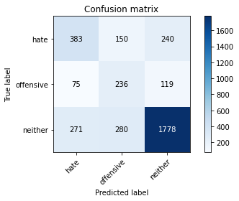

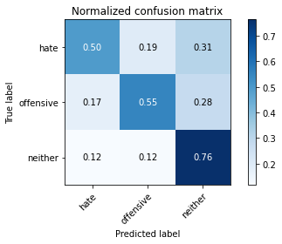

precision recall f1-score support

hate 0.53 0.50 0.51 773

offensive 0.35 0.55 0.43 430

neither 0.83 0.76 0.80 2329

accuracy 0.68 3532

macro avg 0.57 0.60 0.58 3532

weighted avg 0.71 0.68 0.69 3532

average eval_loss: 1.5049088284120722, accuracy: 0.678652321630804

training 9 epoch...

26.6221182346344 seconds used......

9 training finished! average train loss: 0.008481523051587454

evaluating...

Confusion matrix, without normalization

[[ 396 118 259]

[ 81 212 137]

[ 277 192 1860]]

Normalized confusion matrix

[[0.51228978 0.15265201 0.33505821]

[0.18837209 0.49302326 0.31860465]

[0.11893517 0.08243881 0.79862602]]

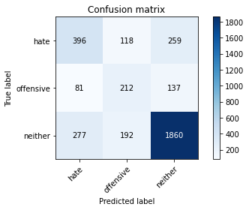

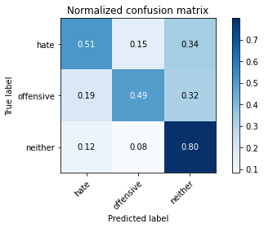

precision recall f1-score support

hate 0.53 0.51 0.52 773

offensive 0.41 0.49 0.45 430

neither 0.82 0.80 0.81 2329

accuracy 0.70 3532

macro avg 0.59 0.60 0.59 3532

weighted avg 0.71 0.70 0.70 3532

average eval_loss: 1.5057462335979872, accuracy: 0.6987542468856173

training 10 epoch...

26.524287223815918 seconds used......

10 training finished! average train loss: 0.00749851783428526

evaluating...

Confusion matrix, without normalization

[[ 340 128 305]

[ 66 201 163]

[ 205 163 1961]]

Normalized confusion matrix

[[0.43984476 0.16558862 0.39456662]

[0.15348837 0.46744186 0.37906977]

[0.08802061 0.06998712 0.84199227]]

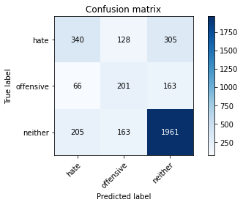

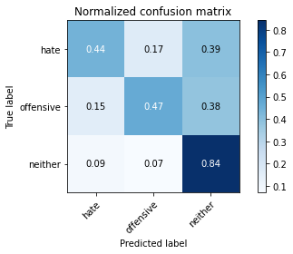

precision recall f1-score support

hate 0.56 0.44 0.49 773

offensive 0.41 0.47 0.44 430

neither 0.81 0.84 0.82 2329

accuracy 0.71 3532

macro avg 0.59 0.58 0.58 3532

weighted avg 0.70 0.71 0.70 3532

average eval_loss: 1.5214019932147473, accuracy: 0.7083805209513023

4 run......

training 1 epoch...

26.470099210739136 seconds used......

1 training finished! average train loss: 0.9079564318937414

evaluating...

Confusion matrix, without normalization

[[ 446 50 277]

[ 134 114 182]

[ 330 82 1917]]

Normalized confusion matrix

[[0.57697283 0.06468305 0.35834411]

[0.31162791 0.26511628 0.42325581]

[0.14169171 0.03520824 0.82310004]]

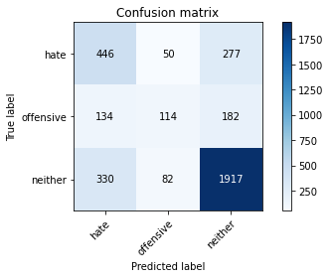

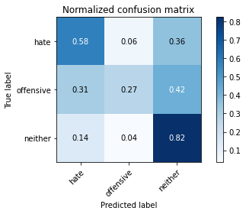

precision recall f1-score support

hate 0.49 0.58 0.53 773

offensive 0.46 0.27 0.34 430

neither 0.81 0.82 0.81 2329

accuracy 0.70 3532

macro avg 0.59 0.56 0.56 3532

weighted avg 0.70 0.70 0.69 3532

average eval_loss: 0.6894717356242702, accuracy: 0.7013023782559457

training 2 epoch...

26.61523151397705 seconds used......

2 training finished! average train loss: 0.6260073691168252

evaluating...

Confusion matrix, without normalization

[[ 365 58 350]

[ 91 135 204]

[ 220 66 2043]]

Normalized confusion matrix

[[0.47218629 0.07503234 0.45278137]

[0.21162791 0.31395349 0.4744186 ]

[0.09446114 0.02833834 0.87720052]]

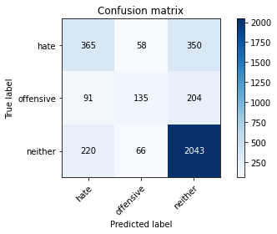

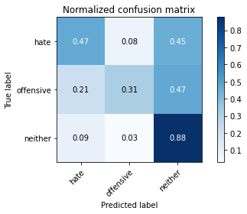

precision recall f1-score support

hate 0.54 0.47 0.50 773

offensive 0.52 0.31 0.39 430

neither 0.79 0.88 0.83 2329

accuracy 0.72 3532

macro avg 0.62 0.55 0.58 3532

weighted avg 0.70 0.72 0.70 3532

average eval_loss: 0.6115019006580956, accuracy: 0.7199886749716874

training 3 epoch...

26.54417610168457 seconds used......

3 training finished! average train loss: 0.4147967458428705

evaluating...

Confusion matrix, without normalization

[[ 462 93 218]

[ 109 204 117]

[ 342 198 1789]]

Normalized confusion matrix

[[0.59767141 0.12031048 0.28201811]

[0.25348837 0.4744186 0.27209302]

[0.14684414 0.08501503 0.76814083]]

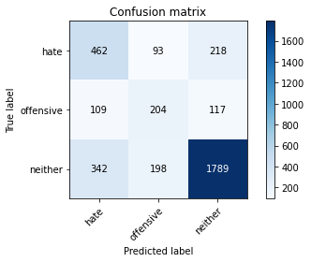

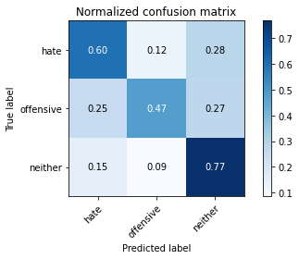

precision recall f1-score support

hate 0.51 0.60 0.55 773

offensive 0.41 0.47 0.44 430

neither 0.84 0.77 0.80 2329

accuracy 0.70 3532

macro avg 0.59 0.61 0.60 3532

weighted avg 0.72 0.70 0.70 3532

average eval_loss: 0.7551234438594452, accuracy: 0.6950736126840317

training 4 epoch...

26.544788360595703 seconds used......

4 training finished! average train loss: 0.1983686073902337

evaluating...

Confusion matrix, without normalization

[[ 401 137 235]

[ 83 212 135]

[ 297 220 1812]]

Normalized confusion matrix

[[0.51875809 0.17723157 0.30401035]

[0.19302326 0.49302326 0.31395349]

[0.12752254 0.09446114 0.77801632]]

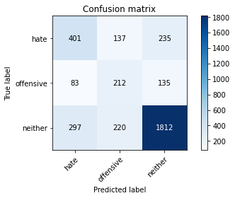

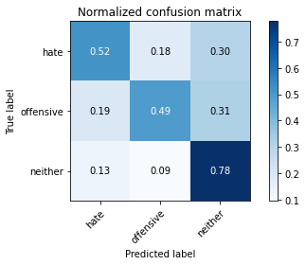

precision recall f1-score support

hate 0.51 0.52 0.52 773

offensive 0.37 0.49 0.42 430

neither 0.83 0.78 0.80 2329

accuracy 0.69 3532

macro avg 0.57 0.60 0.58 3532

weighted avg 0.71 0.69 0.69 3532

average eval_loss: 0.9093580029610187, accuracy: 0.6865798414496036

training 5 epoch...

26.577796697616577 seconds used......

5 training finished! average train loss: 0.07524868109783925

evaluating...

Confusion matrix, without normalization

[[ 393 128 252]

[ 79 215 136]

[ 279 200 1850]]

Normalized confusion matrix

[[0.5084088 0.16558862 0.32600259]

[0.18372093 0.5 0.31627907]

[0.1197939 0.08587377 0.79433233]]

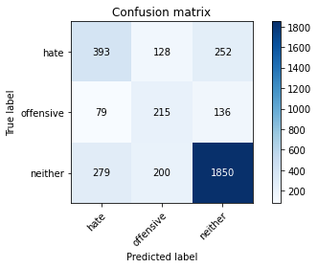

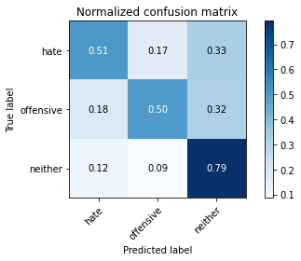

precision recall f1-score support

hate 0.52 0.51 0.52 773

offensive 0.40 0.50 0.44 430

neither 0.83 0.79 0.81 2329

accuracy 0.70 3532

macro avg 0.58 0.60 0.59 3532

weighted avg 0.71 0.70 0.70 3532

average eval_loss: 1.1072816827708045, accuracy: 0.6959229898074745

training 6 epoch...

26.473581552505493 seconds used......

6 training finished! average train loss: 0.037546355345779485

evaluating...

Confusion matrix, without normalization

[[ 418 82 273]

[ 98 171 161]

[ 295 107 1927]]

Normalized confusion matrix

[[0.54075032 0.10608021 0.35316947]

[0.22790698 0.39767442 0.3744186 ]

[0.1266638 0.04594246 0.82739373]]

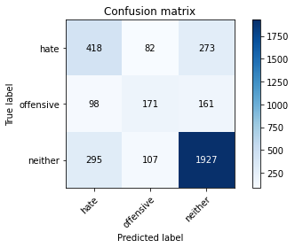

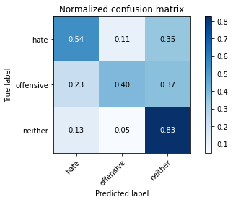

precision recall f1-score support

hate 0.52 0.54 0.53 773

offensive 0.47 0.40 0.43 430

neither 0.82 0.83 0.82 2329

accuracy 0.71 3532

macro avg 0.60 0.59 0.59 3532

weighted avg 0.71 0.71 0.71 3532

average eval_loss: 1.1322241034674443, accuracy: 0.7123442808607021

training 7 epoch...

26.532315254211426 seconds used......

7 training finished! average train loss: 0.021490429687272647

evaluating...

Confusion matrix, without normalization

[[ 507 52 214]

[ 163 136 131]

[ 407 110 1812]]

Normalized confusion matrix

[[0.65588616 0.06727038 0.27684347]

[0.37906977 0.31627907 0.30465116]

[0.17475311 0.04723057 0.77801632]]

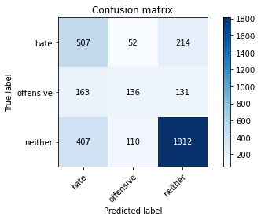

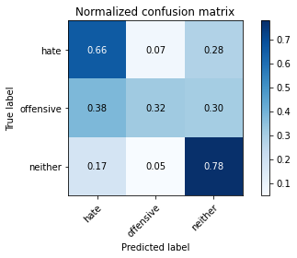

precision recall f1-score support

hate 0.47 0.66 0.55 773

offensive 0.46 0.32 0.37 430

neither 0.84 0.78 0.81 2329

accuracy 0.70 3532

macro avg 0.59 0.58 0.58 3532

weighted avg 0.71 0.70 0.70 3532

average eval_loss: 1.283635199827663, accuracy: 0.6950736126840317

training 8 epoch...

26.527634382247925 seconds used......

8 training finished! average train loss: 0.016005743251298554

evaluating...

Confusion matrix, without normalization

[[ 405 136 232]

[ 89 213 128]

[ 291 236 1802]]

Normalized confusion matrix

[[0.52393273 0.1759379 0.30012937]

[0.20697674 0.49534884 0.29767442]

[0.12494633 0.10133104 0.77372263]]

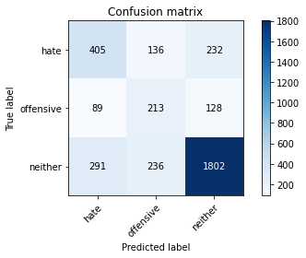

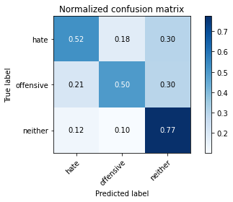

precision recall f1-score support

hate 0.52 0.52 0.52 773

offensive 0.36 0.50 0.42 430

neither 0.83 0.77 0.80 2329

accuracy 0.69 3532

macro avg 0.57 0.60 0.58 3532

weighted avg 0.71 0.69 0.69 3532

average eval_loss: 1.412025277897463, accuracy: 0.6851642129105323

training 9 epoch...

26.5271155834198 seconds used......

9 training finished! average train loss: 0.008971573004279943

evaluating...

Confusion matrix, without normalization

[[ 428 80 265]

[ 101 177 152]

[ 300 121 1908]]

Normalized confusion matrix

[[0.55368693 0.10349288 0.34282018]

[0.23488372 0.41162791 0.35348837]

[0.12881065 0.05195363 0.81923572]]

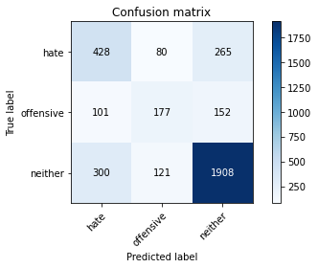

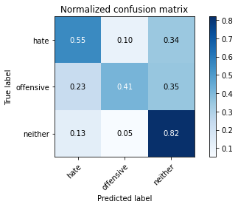

precision recall f1-score support

hate 0.52 0.55 0.53 773

offensive 0.47 0.41 0.44 430

neither 0.82 0.82 0.82 2329

accuracy 0.71 3532

macro avg 0.60 0.59 0.60 3532

weighted avg 0.71 0.71 0.71 3532

average eval_loss: 1.349526804403565, accuracy: 0.7114949037372593

training 10 epoch...

26.559941053390503 seconds used......

10 training finished! average train loss: 0.019383742396979976

evaluating...

Confusion matrix, without normalization

[[ 406 96 271]

[ 99 185 146]

[ 260 150 1919]]

Normalized confusion matrix

[[0.52522639 0.12419146 0.35058215]

[0.23023256 0.43023256 0.33953488]

[0.1116359 0.06440532 0.82395878]]

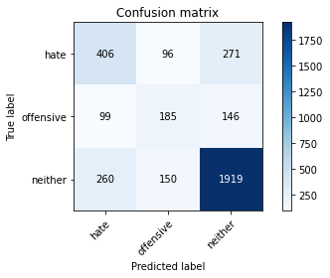

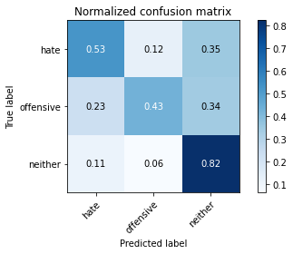

precision recall f1-score support

hate 0.53 0.53 0.53 773

offensive 0.43 0.43 0.43 430

neither 0.82 0.82 0.82 2329

accuracy 0.71 3532

macro avg 0.59 0.59 0.59 3532

weighted avg 0.71 0.71 0.71 3532

average eval_loss: 1.3521658197718824, accuracy: 0.7106455266138165

5 run......

training 1 epoch...

26.55962634086609 seconds used......

1 training finished! average train loss: 0.8857595219331629

evaluating...

Confusion matrix, without normalization

[[ 437 15 321]

[ 130 65 235]

[ 300 38 1991]]

Normalized confusion matrix

[[0.56532988 0.01940492 0.4152652 ]

[0.30232558 0.15116279 0.54651163]

[0.12881065 0.01631602 0.85487334]]

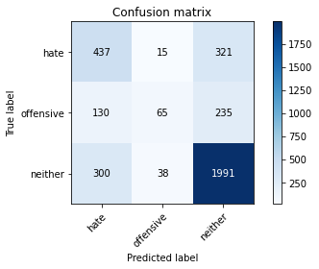

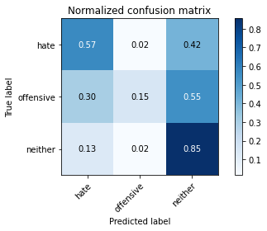

precision recall f1-score support

hate 0.50 0.57 0.53 773

offensive 0.55 0.15 0.24 430

neither 0.78 0.85 0.82 2329

accuracy 0.71 3532

macro avg 0.61 0.52 0.53 3532

weighted avg 0.69 0.71 0.68 3532

average eval_loss: 0.6566979964237428, accuracy: 0.7058323895809739

training 2 epoch...

26.53778648376465 seconds used......

2 training finished! average train loss: 0.625341716058114

evaluating...

Confusion matrix, without normalization

[[ 582 22 169]

[ 225 98 107]

[ 558 89 1682]]

Normalized confusion matrix

[[0.75291074 0.02846054 0.21862872]

[0.52325581 0.22790698 0.24883721]

[0.23958781 0.03821383 0.72219837]]

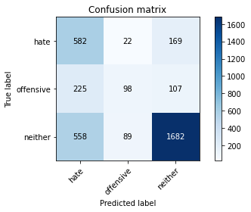

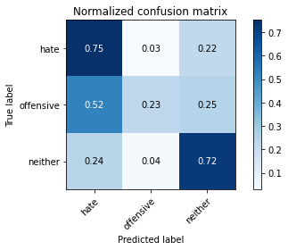

precision recall f1-score support

hate 0.43 0.75 0.54 773

offensive 0.47 0.23 0.31 430

neither 0.86 0.72 0.78 2329

accuracy 0.67 3532

macro avg 0.58 0.57 0.55 3532

weighted avg 0.72 0.67 0.67 3532

average eval_loss: 0.7332155611892205, accuracy: 0.6687429218573047

training 3 epoch...

26.54826855659485 seconds used......

3 training finished! average train loss: 0.4212007217985742

evaluating...

Confusion matrix, without normalization

[[ 441 101 231]

[ 107 188 135]

[ 321 171 1837]]

Normalized confusion matrix

[[0.57050453 0.13065977 0.29883571]

[0.24883721 0.4372093 0.31395349]

[0.13782739 0.07342207 0.78875054]]

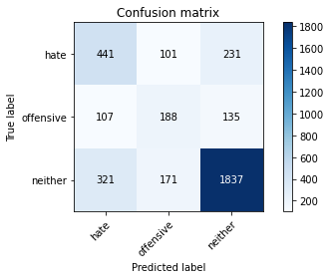

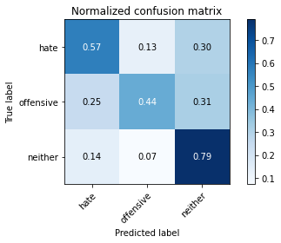

precision recall f1-score support

hate 0.51 0.57 0.54 773

offensive 0.41 0.44 0.42 430

neither 0.83 0.79 0.81 2329

accuracy 0.70 3532

macro avg 0.58 0.60 0.59 3532

weighted avg 0.71 0.70 0.70 3532

average eval_loss: 0.7210011002370866, accuracy: 0.6981879954699887

training 4 epoch...

26.53279137611389 seconds used......

4 training finished! average train loss: 0.23330571149092386

evaluating...

Confusion matrix, without normalization

[[ 409 118 246]

[ 84 208 138]

[ 270 202 1857]]

Normalized confusion matrix

[[0.52910737 0.15265201 0.31824062]

[0.19534884 0.48372093 0.32093023]

[0.11592958 0.0867325 0.79733791]]

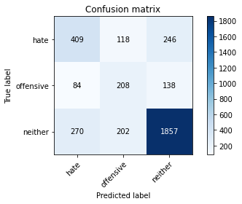

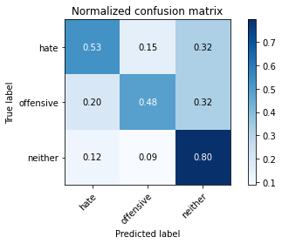

precision recall f1-score support

hate 0.54 0.53 0.53 773

offensive 0.39 0.48 0.43 430

neither 0.83 0.80 0.81 2329

accuracy 0.70 3532

macro avg 0.59 0.60 0.59 3532

weighted avg 0.71 0.70 0.71 3532

average eval_loss: 0.8422217198179267, accuracy: 0.7004530011325029

training 5 epoch...

26.499932527542114 seconds used......

5 training finished! average train loss: 0.11627747195170206

evaluating...

Confusion matrix, without normalization

[[ 375 138 260]

[ 76 219 135]

[ 220 223 1886]]

Normalized confusion matrix

[[0.4851229 0.17852523 0.33635188]

[0.17674419 0.50930233 0.31395349]

[0.09446114 0.09574925 0.80978961]]

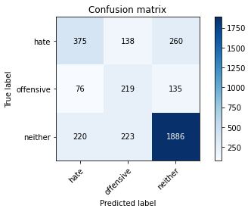

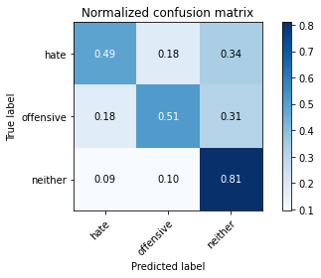

precision recall f1-score support

hate 0.56 0.49 0.52 773

offensive 0.38 0.51 0.43 430

neither 0.83 0.81 0.82 2329

accuracy 0.70 3532

macro avg 0.59 0.60 0.59 3532

weighted avg 0.71 0.70 0.71 3532

average eval_loss: 0.9987721114845599, accuracy: 0.7021517553793885

training 6 epoch...

26.55857801437378 seconds used......

6 training finished! average train loss: 0.05238553076325094

evaluating...

Confusion matrix, without normalization

[[ 324 176 273]

[ 54 237 139]

[ 159 251 1919]]

Normalized confusion matrix

[[0.41914618 0.22768435 0.35316947]

[0.1255814 0.55116279 0.32325581]

[0.06826964 0.10777158 0.82395878]]

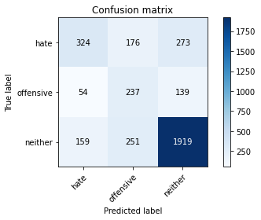

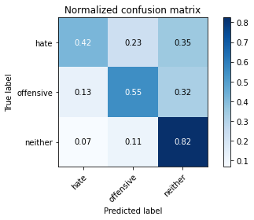

precision recall f1-score support

hate 0.60 0.42 0.49 773

offensive 0.36 0.55 0.43 430

neither 0.82 0.82 0.82 2329

accuracy 0.70 3532

macro avg 0.59 0.60 0.58 3532

weighted avg 0.72 0.70 0.70 3532

average eval_loss: 1.1804212550658963, accuracy: 0.7021517553793885

training 7 epoch...

26.640002727508545 seconds used......

7 training finished! average train loss: 0.02671057977782124

evaluating...

Confusion matrix, without normalization

[[ 395 131 247]

[ 83 212 135]

[ 240 213 1876]]

Normalized confusion matrix

[[0.51099612 0.1694696 0.31953428]

[0.19302326 0.49302326 0.31395349]

[0.10304852 0.09145556 0.80549592]]

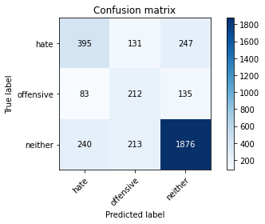

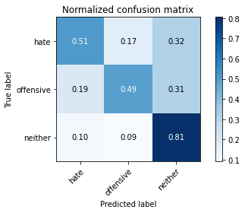

precision recall f1-score support

hate 0.55 0.51 0.53 773

offensive 0.38 0.49 0.43 430

neither 0.83 0.81 0.82 2329

accuracy 0.70 3532

macro avg 0.59 0.60 0.59 3532

weighted avg 0.71 0.70 0.71 3532

average eval_loss: 1.283627753035497, accuracy: 0.7030011325028312

training 8 epoch...

26.56978487968445 seconds used......

8 training finished! average train loss: 0.017927469648009932

evaluating...

Confusion matrix, without normalization

[[ 299 176 298]

[ 43 236 151]

[ 138 226 1965]]

Normalized confusion matrix

[[0.38680466 0.22768435 0.385511 ]

[0.1 0.54883721 0.35116279]

[0.0592529 0.09703736 0.84370975]]

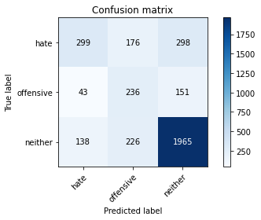

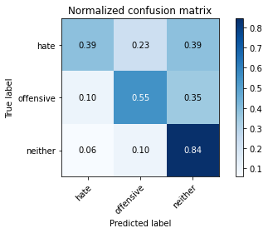

precision recall f1-score support

hate 0.62 0.39 0.48 773

offensive 0.37 0.55 0.44 430

neither 0.81 0.84 0.83 2329

accuracy 0.71 3532

macro avg 0.60 0.59 0.58 3532

weighted avg 0.72 0.71 0.70 3532

average eval_loss: 1.4307546409341576, accuracy: 0.7078142695356738

training 9 epoch...

26.53494119644165 seconds used......

9 training finished! average train loss: 0.013111987181165366

evaluating...

Confusion matrix, without normalization

[[ 419 104 250]

[ 107 187 136]

[ 290 195 1844]]

Normalized confusion matrix

[[0.54204398 0.13454075 0.32341527]

[0.24883721 0.43488372 0.31627907]

[0.12451696 0.08372692 0.79175612]]

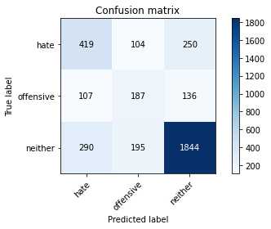

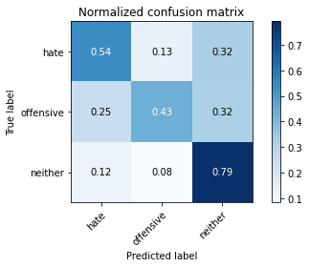

precision recall f1-score support

hate 0.51 0.54 0.53 773

offensive 0.38 0.43 0.41 430

neither 0.83 0.79 0.81 2329

accuracy 0.69 3532

macro avg 0.58 0.59 0.58 3532

weighted avg 0.70 0.69 0.70 3532

average eval_loss: 1.3339149530998058, accuracy: 0.6936579841449604

training 10 epoch...

26.502731800079346 seconds used......

10 training finished! average train loss: 0.005910319676545709

evaluating...

Confusion matrix, without normalization

[[ 400 110 263]

[ 87 205 138]

[ 238 180 1911]]

Normalized confusion matrix

[[0.51746442 0.14230272 0.34023286]

[0.20232558 0.47674419 0.32093023]

[0.10218978 0.07728639 0.82052383]]

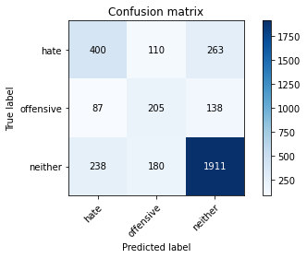

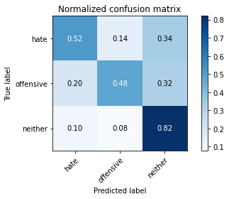

precision recall f1-score support

hate 0.55 0.52 0.53 773

offensive 0.41 0.48 0.44 430

neither 0.83 0.82 0.82 2329

accuracy 0.71 3532

macro avg 0.60 0.60 0.60 3532

weighted avg 0.72 0.71 0.71 3532

average eval_loss: 1.4240910969043181, accuracy: 0.7123442808607021